**Unleash the AI Director**

The Director in Left 4 Dead is a key component to making the game work. The Director is effectively the player's enemy in Left 4 Dead. It controls the zombies, panic events and special infected. It also is responsible for adding variation to each game. Adding the director to your map is simple, just place a new point entity with "**info_director**" assigned as the type. In the properties of this entity give the director a name. We simply gave it the name "Director". The "Name" of an entity is what allows the entity to be addressable object in the game world. This means that this object can be given input from another entity using the built-in "Input/Output" scripting system inside Hammer. In this case we will use another special object to tell the director to start the panic effect that sends hordes of zombies towards the survivors.

**Triggering an Event**

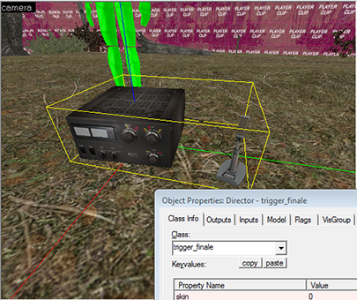In order to trigger our game finale we need to place a object for the player to interact with. The simplest way to do this is to place a "**trigger_finale**" point entity. You can choose any model for this trigger, in this case we chose the commonly used ham radio model: "**models/props/terror/hamradio.mdl**". But using this radio alone won't trigger a finale. You need to have the trigger_finale object tell the director to start the finale.

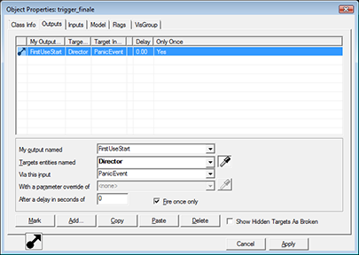To do this, open the Object properties for the trigger_finale and select the "**Outputs**" tab. Press "**Add**", then under "My output named" select: "**FirstUseStart**". Then under "Targets entities named" select "**Director**". Under "Via this input" select "**PanicEvent**". Check "**Fire once only**" to ensure the panic event doesn't happen twice. If you want you can add a delay of a certain amount to this output. For example you could play a 5 second sound clip that tells the players to get ready. But for our basic map we will simply make it start instantly.

### Force the Game Mode

By default, compiled maps are made to run in single-player campaign mode. But in order to test our survival map we need to tell the game our map is actually a survival map. We can do this by using another point entity that forces a console command on the server. Place a "**point_servercommand**" entity in your map. Give it a name, such as "**Survival_activator**". Now you need to pass this entity actual console command. You do this by placing another entity called "**Logic_auto**". A logic_auto entity can send out a command the instant a map is launched. In this case add an output with the following settings: My Output name: - "**OnMapSpawn**", Target Entities: - "**Survival_activator**", Via input - "**Command**". Refer to the screenshot below.

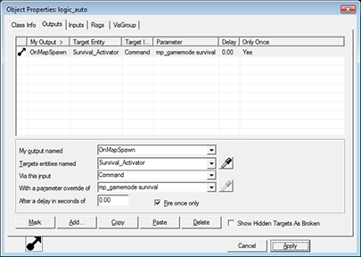

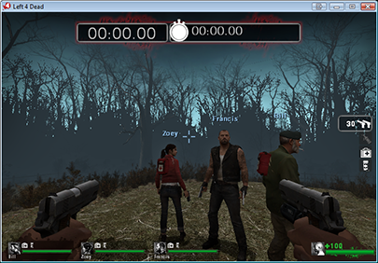Finally, inside the box labeled "With a parameter override of" enter the following console command: "**mp_gamemode survival**". And again select "**Fire Once only**". This will now force the game to run in survival mode any time you load this map. The director will detect this game mode and automatically convert the panic event into a "survival panic event" which sends our players a never-ending horde of zombies.

At this point compile the map and test that the survival clock shows up at the top of the game screen. You can also run around and test that the player can't leave the middle of the game map.

## Zombie Navigation

If you activate the Ham Radio you may note that the survival timer at the top of the screen starts running, but no zombies actually spawn and start attacking you. This is because your map is missing a key ingredient: A **navigation mesh**. A navigation mesh is a grid that covers all the walkable areas of your map. It tells the game where the survivors, zombies, and special infected can travel. Because a survival map doesn't require the players to travel to a safe room, or any rescue points, the navigation mesh for a survival map is pretty simple.

To generate a navigation mesh you need to load your map in Left 4 Dead rather then in Hammer. Rather then re-compile your map, you can do this by simply opening Left 4 Dead to the main menu. Press "~" on your keyboard to bring up the console. In this console type: "map" and then press space, then start typing the name or your map. You can search for console commands in a similar fashion to the material browser. In our case the command is "map l4d_sv_cabin”

Now that you have your map loaded we need to generate the navigation mesh. To do this you first need to enable game cheats by entering: "**Sv_cheats 1**" into the console. Then, enter navigation editing mode by typing in: "**nav_edit 1**" into the console. You now need to tell the game where to start generating zombies from. Aim your gun at the ground beneath your feet, then open the console, and type in the command: "**nav_mark_walkable**". A small purple pyramid should show up where you aimed. You can place multiple walkable points to tell the game that zombies can spawn on say the top of a cliff, but for now one spawn point will do.

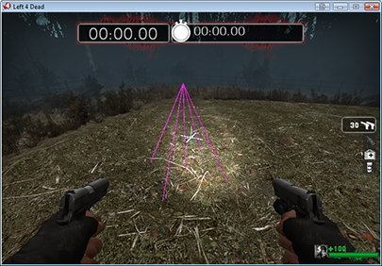

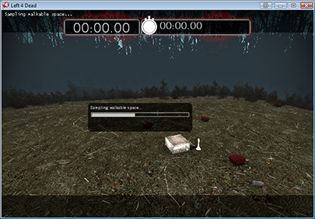From here, all you have to do is enter the console command: "**Nav_generate**". The survivors and any zombies will be removed and the game will start a progress bar. Generating the navigation mesh can take a very long time depending on the complexity of your map. In our case the terrain can greatly complicate and break up the navigation mesh into many pieces. You don't have to generate a new navigation mesh each time you change your map, but there isn't enough room in this guide to cover all the various navigation mesh commands. We will be covering only a few basic commands here.

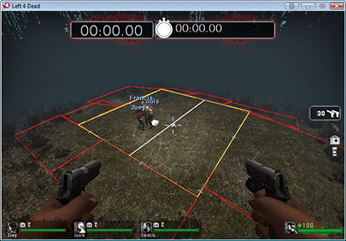Once the navigation mesh finishes generating the game will reload your map, but the map will still tell you there are Nav Errors upon load. That is because the director is missing a few key navigation elements.

### Basic Navigation Commands

The game director relies on the navigation mesh in order to determine where to spawn zombies, and where the survivors may potentially be located during an event. To pass this information onto the director you apply labels to areas inside your navigation mesh. Because our map is a survival map and is very basic, we need only a few commands to tell the director that our entire map is a "finale" area. Open the console and enter navigation edit mode. Then enter the command "**z_debug 1**" into the console. This command shows you the labels of each area in the map.

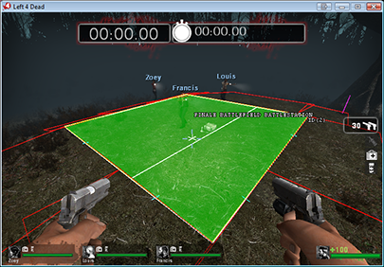To apply a label to all areas of your map: aim at a navigation area type in: "**nav_flood_select**". This should select all the connected navigation areas in your whole map. Then enter: "**mark finale**". This will mark each and every box with the "Finale" label. This tells the game that the survivors and zombies need to be in theses areas during the final event. In our case it happens to be the whole map. We need to add one more command to the whole nav mesh, so again enter: "**nav_flood_select**", and then enter "**mark battlefield**". This label is similar to finale and required for all of the survival map.

There is one last command we need to add in order to make our map work well. That is to tell the survivors that are not under human control, where to best hunker down for the fight. To do this we can mark the middle of our map with "**mark BATTLESTATION**". The survivor bots will automatically be attracted to stand on these navigation areas if a human player is also near the same area. You should also make the area where the players start the game with "**mark PLAYER_START**".

### Visibility and Zombie Hordes

Zombies are spawned into Left 4 Dead using a few different basic rules. Don't spawn zombies if the players can potentially see the area the zombie spawn in. This prevents zombies from appearing to pop-up out of no where. Spawn zombies in areas that have more then one way in. For example, it doesn't make sense to spawn a horde of 50 zombies inside a bathroom right next to the survivors. Although that still sometimes happens. So the game often prefers to spawn zombies in areas that are either open to the skybox, or connected to other rooms in order to simulate that the zombies came from some other location beyond. The game also attempts to space zombies apart from each other, so larger rooms typically spawn more zombies then smaller rooms.

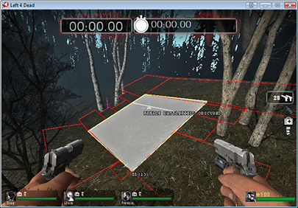

Because out map is a single large outdoor world the survivors can potentially see the entire map from any point near the middle. This causes a problem for the director as it doesn't take game fog into account when determining if the players can see a certain area. It only calculates line of sight. But our current fog settings are such that we can spawn zombies near the edges of the map without worrying if the players can see these zombies. In order to tell the game that it can spawn zombies inside an area, even if the player can potentially see this area, you can mark a navigation area with the command "**mark OBSCURED**". In the case of our map you can move out to the far edges of the map and mark the larger navigation areas as obscured. If you can't move past your player-blocking Clip Brushes, you can enter the console command: "**noclip**" in order to fly across the map.

### Analyze Navigation Paths

The last step before the director can start spawning zombies into the map it needs to analyze all the various labels and changes you have made to your map. To do this enter the command: "**nav_analyze**" into the console. You need to do this command after making any changes to your map or navigation mesh. This step should be shorter then the nav_generate, but can still take some time on complex navigation meshes. Once the analyze program finishes, exit nav edit mode by typing in: "**nav_edit 0**" and "**z_debug 0**" into the console. Exit cheats mode by typing in "**sv_cheats 0**" into the console. Then exit the map by going to the main menu.

### Run Your Map!

Your map is now 100% playable. You should be able to load it from the console, start the finale trigger, and start fighting off zombie hordes.

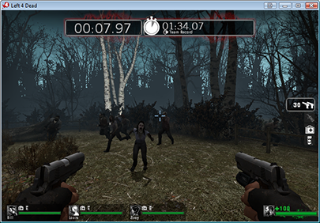

The next two parts of this guide will show you how to use SketchUp to build and import a realistic looking cabin and a wooden barrel into Hammer, completing your "cabin in the woods" map.

COMMENTS Login or register to post comments

avatar

ryanemm you have it on a

Submitted by Pecano on Sat, 02/06/2010 - 10:44am

ryanemm you have it on a wire frame view. You need to click view then select 3D Textured Polygons.

Login or register to post comments

avatar

dont work help??

Submitted by ryanemm93 on Fri, 02/05/2010 - 5:09pm

i followed the instructions step by step precisely

but when i click enter after creating the box and selected the texture, the box is not yellow and solid

it is just outlines....

anyone know anything aboout that ?????

Login or register to post comments

avatar

C-map

Submitted by linktocomputer on Wed, 02/03/2010 - 1:58am

C-map - Authorized distributor of c-map, c-map max, c-map nt+, navionics, livecharts, SeaPro

dodge parts

Login or register to post comments

avatar

importing materials

Submitted by J_man86 on Sat, 01/16/2010 - 11:06am

I'm trying to import the materials from l4d but when in sketchup under the plugin tab there is only 2 options in the drop down menu and they are both "export", so i don't know how to import the materials. please help.

Login or register to post comments

avatar

Re: Custom props

Submitted by ZapWizard on Tue, 12/29/2009 - 12:41pm

You package the custom props along with your final VMF, which is a sort of ZIP style packaged file with all the files related to your map or campaign.

Login or register to post comments

avatar

Great Work - Thanks!

Submitted by SMTB1963 on Tue, 12/29/2009 - 6:48am

After initially reading this article soon after it was published, I went searching for more L4D "how-to" stuff on the net...this is by far the best written & explained tutorial for those new to L4D modding I've found so far. Also, the links to the tools & utilities were great time savers.

Thanks MAXIMUMPC and Joshua Driggs!

ps - anyone reading this should check out ZAPWizard's other projects - he's definately into some cool stuff.

Login or register to post comments

avatar

Yellow Cubes

Submitted by mdpaustin on Thu, 12/24/2009 - 8:24pm

Pikalex,

Go to:

Tools->Options->3dViews

Increase the Model Render Distance and see if that solves the problem.

Login or register to post comments

avatar

custom props

Submitted by jackmueth on Wed, 12/23/2009 - 8:57pm

when using a custom prop, do i have to install the prop on every computer i use it on, or does the map save the model info within it?

Login or register to post comments

avatar

Yellow cubes instead of models?

Submitted by pikalex88 on Tue, 12/22/2009 - 6:52pm

This looks like a very interesting and detailed tutorial, but I'm having a problem on page 2. When I place the static prop tree models in the 3D window they appear as giant yellow cubes and I cannot actually see the tree model unless I move the camera inside the box, where it cannot see other models. In the picture from the tutorial multiple trees can be seen, how is this possible? Does anyone else have this problem or know what I'm missing? I also cannot see grass after I paint alpha within the 3D window, though when I run the game it is there. That isn't as big a problem, but could maybe be related?

A screenshot of my map running in Hammer if that helps is Here

Login or register to post comments

avatar

Did you make the outer most

Submitted by ZapWizard on Tue, 12/29/2009 - 12:44pm

Did you make the outer most cube of your world hollow?

As for the grass: Along the menu bar there is a setting to view everything as high quality, grass and leaves are hidden in all but the highest quality setting.

Login or register to post comments

avatar

"Fix the roof line"

Submitted by klewd on Tue, 12/15/2009 - 7:33pm

This is one of the best tutorials I've read, but unfortunately there is one point where I think it could be better explained. How do you make everything align suddenly at page 8? It's not aligned at page 7, and there's no prior explanation, that I can see at least.

Login or register to post comments

avatar

It is explained in the first

Submitted by ZapWizard on Sun, 12/20/2009 - 7:38am

It is explained in the first paragraph on page 8. What you need do is to cut the face at the edge of the balcony and then pull it out until the center of the roof line meets close to the center of the top of the block.

Login or register to post comments

avatar

Zap, first thanks for the

Submitted by mdpaustin on Sun, 12/20/2009 - 6:26pm

Zap, first thanks for the great tutorial. I too was having difficulty getting the roof center line adjusted. Once I clicked on "Project textures from photo" again, everything worked out.

M

Login or register to post comments

avatar

Wow

Submitted by emperor3d on Thu, 12/10/2009 - 9:29pm

You gotta give major props to MPC for this rather thorough tutorial. Very fine job indeed. Good job boys and girls.

Login or register to post comments

avatar

how

Submitted by hammerfell on Thu, 12/10/2009 - 8:06am

btw how different would this be from l4d2? can we do this using roughly the same process in l4d2?

Login or register to post comments

avatar

Just the same.

Submitted by ZapWizard on Fri, 12/11/2009 - 7:30am

I actually am in the beta for the L4D2 SDK, the steps to make a map and import assets is just the same as for L4D1.

Login or register to post comments

avatar

The maps you create will

Submitted by willsmith on Thu, 12/10/2009 - 12:19pm

The maps you create will work in L4D2 when the SDK comes out.

Login or register to post comments

avatar

Wow, one of the BEST

Submitted by Xylogeist on Thu, 12/10/2009 - 7:54am

Wow, one of the BEST how-to's by far.

Login or register to post comments

avatar

Too bad nobody actually

Submitted by lunchbox73 on Thu, 12/10/2009 - 7:04am

Too bad nobody actually plays Left 4 Dead anymore. Even weeks before the sequel there were hardly any games out there. Almost impossible to get a full versus game going.

Login or register to post comments

avatar

This guide will also work

Submitted by ZapWizard on Fri, 12/11/2009 - 7:45am

This guide will also work for the L4D2 SDK, or really any Source based game.

Login or register to post comments

avatar

No kidding, and this was

Submitted by DBsantos77 on Thu, 12/10/2009 - 8:43am

No kidding, and this was when STEAM had a $7 special on the first one.

:/

-Santos

Teh Rig:

AMD Phenom 720 (Unlocked to Quad, Stable @ 3.6 Ghz 1.47v)

Gigabyte Micro ATX 785gx Motherboard

G.Skill 4GB 1333 DDR3 8-8-8-21 @ 1.6v

HIS ATI Radeon HD4670 (CCC OC'd)

550w Corsai

Login or register to post comments

avatar

kudos

Submitted by hammerfell on Thu, 12/10/2009 - 6:21am

Definitely one of the coolest how too articles ever! I'm totally making my house Into an L4D level... and then after that... My friend's house... and after that... anything I can get blue prints and pictures of O_O

Login or register to post comments

avatar

work

Submitted by Yusonice on Thu, 12/10/2009 - 4:51am

Too much work!

Ill sticck to downloading the maps

Login or register to post comments

avatar

Great level of detail. Now

Submitted by Veritas19 on Wed, 12/09/2009 - 9:57pm

Great level of detail. Now do one for Team Fortress 2!

Login or register to post comments

avatar

This has to be the most epic

Submitted by vistageek on Wed, 12/09/2009 - 9:27pm

This has to be the most epic and well done how to i have ever seen. Great job. Tanks so much! (pun intended)

Login or register to post comments

avatar

This is sick, is there

Submitted by DBsantos77 on Wed, 12/09/2009 - 7:45pm

This is sick, is there anyway to achieve this by making models in 3DS or Maya?

-Santos

Teh Rig:

AMD Phenom 720 (Unlocked to Quad, Stable @ 3.6 Ghz 1.45v)

Gigabyte Micro ATX 785gx Motherboard

G.Skill 4GB 1333 DDR3 8-8-8-21 @ 1.6v

HIS ATI Radeon HD4670 (CCC OC'd)

550w Corsai

Login or register to post comments

avatar

or

Submitted by nekollx on Thu, 12/10/2009 - 3:24pm

or Daz/Cararra/Poser?

------------------------------

Coming soon to Lulu.com --Tokusatsu Heroes--

Five teenagers, one alien ghost, a robot, and the fate of the world.

Login or register to post comments